**Lab Exercises**

Class: 软件1803 Name: 温家清 StuID:__201816040314 _

Date: 2019.11.25 Score:

**Lab Exercise 1 — String Concatenation**

**I Lab Objectives**

In this lab, you will practice:

1. Overloading the + operator to allow String objects to be concatenated.
2. Writing function prototypes for overloaded operators.
3. Using overloaded operators.

**II Description of the Problem**

String **concatenation（连接）**requires two operands—the two strings that are to be concatenated. In the String case study, we showed how to implement an overloaded concatenation operator that concatenates the second String object to the right of the first String object, thus modifying the first String object. In some applications, it is desirable to produce a concatenated String object without modifying the String arguments. Implement operator+ to allow operations such as

string1 = string2 + string3;

in which neither operand is modified.

**III Sample Output**

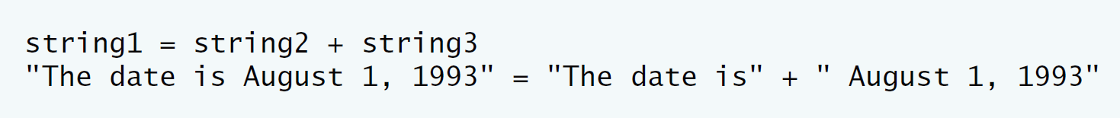

**IV Problem-Solving Tips**

1. The overloaded + operator should be a member function of class String and should take one parameter, a const reference to a String.
2. The + operator function should use return type String.
3. The strcat function can be used to concatenate pointer-based strings.

**V Your Solution**

// Lab 1: String.h

// Header file for class String.

#ifndef STRING_H

#define STRING_H

#include <iostream>

#include <cstring>

#include <cassert>

using namespace std;

class String

{

friend ostream &operator<<( ostream &output, const String &s );

public:

String( const char * const = "" ); // conversion constructor

String( const String & ); // copy constructor

~String(); // destructor

const String &operator=( const String & );

/* Write a prototype for the operator+ member function */

const String operator+( const String & );//the number function is to add the parameter object to this object

private:

char *sPtr; // pointer to start of string

int length; // string length

}; // end class String

#endif

// Lab 1: String.cpp

// Member-function definitions for String.cpp

#include <iostream>

using namespace std;

#include <cstring> // strcpy and strcat prototypes

#include "String.h" // String class definition

// conversion constructor: convert a char * to String

String::String( const char * const zPtr )

{

length = strlen( zPtr ); // compute length

sPtr = new char[ length + 1 ]; // allocate storage

assert( sPtr != 0 ); // terminate if memory not allocated

strcpy( sPtr, zPtr ); // copy literal to object

} // end String conversion constructor

// copy constructor

String::String( const String &copy )

{

length = copy.length; // copy length

sPtr = new char[ length + 1 ]; // allocate storage

assert( sPtr ); // ensure memory allocated

strcpy( sPtr, copy.sPtr ); // copy string

} // end String copy constructor

// destructor

String::~String()

{

delete [] sPtr; // reclaim string

} // end destructor

// overloaded = operator; avoids self assignment

const String &String::operator=( const String &right )

{

if ( &right != this ) // avoid self assignment

{

delete [] sPtr; // prevents memory leak

length = right.length; // new String length

sPtr = new char[ length + 1 ]; // allocate memory

assert( sPtr != 0 ); // ensure memory allocated

strcpy( sPtr, right.sPtr ); // copy string

}

else

cout << "Attempted assignment of a String to itself\n";

return *this; // enables concatenated assignments

} // end function operator=

// concatenate right operand and this object and store in temp object

/* Write the header for the operator+ member function */

const String String::operator+( const String &rightObject )

{

/* Declare a temporary String variable named temp */

String temp;

/* Set temp’s length to be the sum of the two argument Strings’ lengthes */

temp.length=length+rightObject.length;//to set the length of the temp object

/* Allocate memory for temp.length + 1 chars and assign the pointer to temp.sPtr */

temp.sPtr=new char[temp.length + 1];// to Allocate memory for temp.length + 1 chars and assign the pointer to temp.sPtr

assert( sPtr !=0 ); // terminate if memory not allocated

/* Copy the left String argument’s contents into temp.sPtr */

strcpy(temp.sPtr,sPtr);//copy the string from sPtr to temp.sPtr

//std::cout<<temp.sPtr<<endl;

/* Write a call to strcat to concatenate the string in right

onto the end of the string in temp */

strcat(temp.sPtr,rightObject.sPtr);//strcat the rightObject.sPtr to temp.sPtr

// std::cout<<temp.sPtr<<endl;

return temp;

/* Return the temporary String */

} // end function operator+

// overloaded output operator

ostream & operator<<( ostream &output, const String &s )

{

output << s.sPtr;

return output; // enables concatenation

} // end function operator<<

// Lab 1: String.cpp

// Member-function definitions for String.cpp

#include <iostream>

using namespace std;

#include <cstring> // strcpy and strcat prototypes

#include "String.h" // String class definition

// conversion constructor: convert a char * to String

String::String( const char * const zPtr )

{

length = strlen( zPtr ); // compute length

sPtr = new char[ length + 1 ]; // allocate storage

assert( sPtr != 0 ); // terminate if memory not allocated

strcpy( sPtr, zPtr ); // copy literal to object

} // end String conversion constructor

// copy constructor

String::String( const String &copy )

{

length = copy.length; // copy length

sPtr = new char[ length + 1 ]; // allocate storage

assert( sPtr ); // ensure memory allocated

strcpy( sPtr, copy.sPtr ); // copy string

} // end String copy constructor

// destructor

String::~String()

{

delete [] sPtr; // reclaim string

} // end destructor

// overloaded = operator; avoids self assignment

const String &String::operator=( const String &right )

{

if ( &right != this ) // avoid self assignment

{

delete [] sPtr; // prevents memory leak

length = right.length; // new String length

sPtr = new char[ length + 1 ]; // allocate memory

assert( sPtr != 0 ); // ensure memory allocated

strcpy( sPtr, right.sPtr ); // copy string

}

else

cout << "Attempted assignment of a String to itself\n";

return *this; // enables concatenated assignments

} // end function operator=

// concatenate right operand and this object and store in temp object

/* Write the header for the operator+ member function */

const String String::operator+( const String &rightObject )

{

/* Declare a temporary String variable named temp */

String temp;

/* Set temp’s length to be the sum of the two argument Strings’ lengthes */

temp.length=length+rightObject.length;//to set the length of the temp object

/* Allocate memory for temp.length + 1 chars and assign the pointer to temp.sPtr */

temp.sPtr=new char[temp.length + 1];// to Allocate memory for temp.length + 1 chars and assign the pointer to temp.sPtr

assert( sPtr !=0 ); // terminate if memory not allocated

/* Copy the left String argument’s contents into temp.sPtr */

strcpy(temp.sPtr,sPtr);//copy the string from sPtr to temp.sPtr

//std::cout<<temp.sPtr<<endl;

/* Write a call to strcat to concatenate the string in right

onto the end of the string in temp */

strcat(temp.sPtr,rightObject.sPtr);//strcat the rightObject.sPtr to temp.sPtr

// std::cout<<temp.sPtr<<endl;

return temp;

/* Return the temporary String */

} // end function operator+

// overloaded output operator

ostream & operator<<( ostream &output, const String &s )

{

output << s.sPtr;

return output; // enables concatenation

} // end function operator<<

运行结果如图：

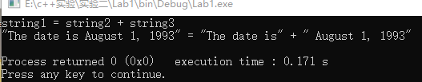**Lab Exercise 2 — Huge Integer**

**I Lab Objectives**

In this lab, you will practice:

1. Overloading arithmetic and comparison operators to enhance a huge integer class, HugeInt**.**
2. Writing function prototypes for overloaded operators.
3. Calling overloaded operator functions.

**II Description of the Problem**

A machine with 32-bit integers can represent integers in the range of approximately –2 billion to +2 billion. This fixed-size restriction is rarely troublesome, but there are applications in which we would like to be able to use a much wider range of integers. This is what C++ was built to do, namely, create powerful new data types. Consider class HugeInt of **Figs. 10.17–10.19.** Study the class carefully, then overload the relational and equality operators. [Note: We do not show an assignment operator or copy constructor for class HugeInt, because the assignment operator and copy constructor provided by the compiler are capable of copying the entire array data member properly.]

**III Sample Output**

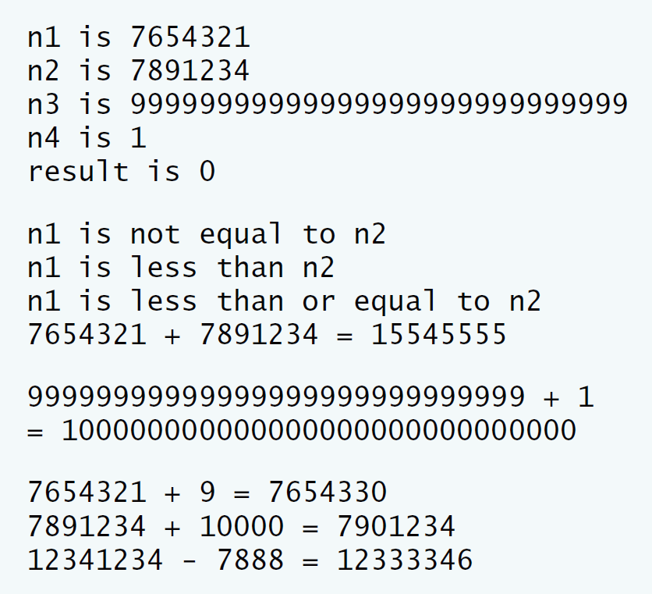

**IV Problem-Solving Tips**

You can implement the !=, >, >= and <= operators in terms of the overloaded == and < operators.

**V Your Solution**

// Lab 2: Hugeint.h

// HugeInt class definition.

#ifndef HUGEINT_H

#define HUGEINT_H

#include <iostream>

using namespace std;

class HugeInt

{

friend ostream &operator<<( ostream &, const HugeInt & );

public:

HugeInt( long = 0 ); // conversion/default constructor

HugeInt( const char * ); // conversion constructor

// addition operator; HugeInt + HugeInt

HugeInt operator+( const HugeInt & ) const;

HugeInt operator-( const HugeInt & ) const;

// addition operator; HugeInt + int

HugeInt operator+( int ) const;

HugeInt operator-( int ) const;

HugeInt operator-( const char * ) const;

// addition operator;

// HugeInt + string that represents large integer value

HugeInt operator+( const char * ) const;

/* Write prototypes for the six relational and equality operators */

bool operator==( const HugeInt &rightObject) const;//a definition for the == operator with a parameter object

bool operator!=( const HugeInt &rightObject ) const;//a definition for the != operator with a parameter object

bool operator<( const HugeInt &rightObject ) const;//a definition for the < operator with a parameter object

bool operator<=( const HugeInt &rightObject ) const;//a definition for the <= operator with a parameter object

bool operator>( const HugeInt &rightObject ) const;//a definition for the > operator with a parameter object

bool operator>=( const HugeInt &rightObject ) const;//a definition for the >= operator with a parameter object

int getLength() const;

private:

short integer[ 30 ];

}; // end class HugeInt

#endif

// Lab 2: Hugeint.cpp

// HugeInt member-function and friend-function definitions.

#include <iostream>

#include <cctype> // isdigit function prototype

#include <cstring> // strlen function prototype

using namespace std;

#include "Hugeint.h" // HugeInt class definition

// default constructor; conversion constructor that converts

// a long integer into a HugeInt object

HugeInt::HugeInt( long value )

{

// initialize array to zero

for ( int i = 0; i <= 29; i++ )

integer[ i ] = 0;

// place digits of argument into array

for ( int j = 29; value != 0 && j >= 0; j-- )

{

integer[ j ] = value % 10;

value /= 10;

} // end for

} // end HugeInt default/conversion constructor

// conversion constructor that converts a character string

// representing a large integer into a HugeInt object

HugeInt::HugeInt( const char *string )

{

// initialize array to zero

for ( int i = 0; i <= 29; i++ )

integer[ i ] = 0;

// place digits of argument into array

int length = strlen( string );

for ( int j = 30 - length, k = 0; j <= 29; j++, k++ )

if ( isdigit( string[ k ] ) )

integer[ j ] = string[ k ] - '0';

} // end HugeInt conversion constructor

// get function calculates length of integer

int HugeInt::getLength() const

{

int i;

for ( i= 0; i <= 29; i++ )

if ( integer[ i ] != 0 )

break; // break when first digit is reached

return 30 - i; // length is from first digit (at i) to end of array

} // end function getLength

// addition operator; HugeInt + HugeInt

HugeInt HugeInt::operator+( const HugeInt &op2 ) const

{

HugeInt temp; // temporary result

int carry = 0;

for ( int i = 29; i >= 0; i-- )

{

temp.integer[ i ] =

integer[ i ] + op2.integer[ i ] + carry;

// determine whether to carry a 1

if ( temp.integer[ i ] > 9 )

{

temp.integer[ i ] %= 10; // reduce to 0-9

carry = 1;

} // end if

else // no carry

carry = 0;

} // end for

return temp; // return copy of temporary object

} // end function operator+

HugeInt HugeInt::operator-( const HugeInt &op2 ) const

{

HugeInt temp; // temporary result

int carry = 0;

int flag=0;

if((*this)>=op2)

{

for ( int i = 29; i >=0; i-- )

{

if(integer[ i ] - op2.integer[ i ]-flag<0)

carry=1;

else

carry=0;

temp.integer[ i ] =

integer[ i ] - op2.integer[ i ] + carry*10-flag;

flag=carry;

// determine whether to carry a 1

}

}

else

{

for ( int i = 29; i >=0; i-- )

{

if(op2.integer[ i ]-integer[ i ]-flag <0)

carry=1;

else

carry=0;

temp.integer[ i ] =

op2.integer[ i ]-integer[ i ] + carry*10-flag;

flag=carry;

}

for(int i=0;i<=29;i++)

if(temp.integer[i]!=0)

{

temp.integer[i]=temp.integer[i]*-1;break;

}

}

return temp; // return copy of temporary object

}

HugeInt HugeInt::operator-( int op2 ) const

{

// convert op2 to a HugeInt, then invoke

// operator- for two HugeInt objects

return *this - HugeInt( op2 );

} // end function operator-

HugeInt HugeInt::operator-( const char *op2 ) const

{

// convert op2 to a HugeInt, then invoke

// operator- for two HugeInt objects

return *this - HugeInt( op2 );

} // end function operator-

// addition operator; HugeInt + int

HugeInt HugeInt::operator+( int op2 ) const

{

// convert op2 to a HugeInt, then invoke

// operator+ for two HugeInt objects

return *this + HugeInt( op2 );

} // end function operator+

// addition operator;

// HugeInt + string that represents large integer value

HugeInt HugeInt::operator+( const char *op2 ) const

{

// convert op2 to a HugeInt, then invoke

// operator+ for two HugeInt objects

return *this + HugeInt( op2 );

} // end function operator+

// equality operator; HugeInt == HugeInt

/* Write a definition for the == operator */

bool HugeInt::operator==( const HugeInt &rightObject ) const

{

int i=0;

for ( i =0 ; i <= 29; i++ )

if ( integer[ i ] != rightObject.integer[i])

break; // break when first digit is reached

if(i==30)

return true;

return false;

}

// inequality operator; HugeInt != HugeInt

/* Write a definition for the != operator

by calling the == operator */

bool HugeInt::operator!=( const HugeInt &rightObject ) const

{

if(*this==rightObject)//call to operator==();

return false;

return true;

}

// less than operator; HugeInt < HugeInt

/* Write a definition for the < operator */

bool HugeInt::operator<( const HugeInt &rightObject ) const

{

int i=0;

for ( i = 0; i <=29; i++ )

if ( integer[ i ] > rightObject.integer[i])//to judge the size;

return false;

else if(integer[ i ] < rightObject.integer[i])//to judge the size;

return true;

if(i==30)

return false;

}

// less than or equal operator; HugeInt <= HugeInt

/* Write a definition for the <= operator

by calling the < and == operators */

bool HugeInt::operator<=( const HugeInt &rightObject ) const

{

if(*this==rightObject||*this<rightObject)//call to operator==() and operator<()

return true;

else

return false;

}

// greater than operator; HugeInt > HugeInt

/* Write a definition for the > operator

by calling the <= operator */

bool HugeInt::operator>( const HugeInt &rightObject ) const

{

if(*this <= rightObject)//call to operator<=()

return false;

else

return true;

}

// greater than or equal operator; HugeInt >= HugeInt

/* Write a definition for the >= operator

by calling the > and == operators */

bool HugeInt::operator>=( const HugeInt &rightObject ) const

{

if(*this >rightObject||*this == rightObject)//call to operator==() and operator>()

return true;

else

return false;

}

// overloaded output operator

ostream& operator<<( ostream &output, const HugeInt &num )

{

int i;

for ( i = 0; ( num.integer[ i ] == 0 ) && ( i <= 29 ); i++ )

; // skip leading zeros

if ( i == 30 )

output << 0;

else

for ( ; i <= 29; i++ )

output << num.integer[ i ];

return output;

} // end function operator<<

// Lab 2: HugeIntTest.cpp

// HugeInt test program.

#include <iostream>

using namespace std;

#include "Hugeint.h"

int main()

{

HugeInt n1( 7654321 );

HugeInt n2( 7891234 );

HugeInt n3( "99999999999999999999999999999" );

HugeInt n4( "1" );

HugeInt n5(12341234);

HugeInt result;

cout << "n1 is " << n1 << "\nn2 is " << n2

<< "\nn3 is " << n3 << "\nn4 is " << n4

<< "\nresult is " << result << "\n\n";

// test relational and equality operators

if ( n1 == n2 )

cout << "n1 equals n2" << endl;

if ( n1 != n2 )

cout << "n1 is not equal to n2" << endl;

if ( n1 < n2 )

cout << "n1 is less than n2" << endl;

if ( n1 <= n2 )

cout << "n1 is less than or equal to n2" << endl;

if ( n1 > n2 )

cout << "n1 is greater than n2" << endl;

if ( n1 >= n2 )

cout << "n1 is greater than or equal to n2" << endl;

result = n1 + n2;

cout << n1 << " + " << n2 << " = " << result << "\n\n";

cout << n3 << " + " << n4 << "\n= " << ( n3 + n4 ) << "\n\n";

result = n1 + 9;

cout << n1 << " + " << 9 << " = " << result << endl;

result = n2 + "10000";

cout << n2 << " + " << "10000" << " = " << result << endl;

result = n5-7888;

cout << n5 << " - " << "7888" << "=" << result <<endl;

} // end main

运行结果如图：

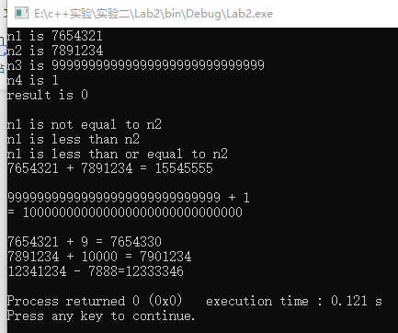

**Lab Exercise 3 — Rational Numbers**

**I Lab Objectives**

In this lab, you will practice:

1. Overloading operators to create a class capable of storing rational numbers (fractions) and performing rational number arithmetic.
2. Writing function prototypes for overloaded operators.
3. Implementing overloaded operator functions.

The follow-up questions and activities also will give you practice:

1. Overloading the << operator.
2. Making a class more robust to prevent runtime errors.

**II Description of the Problem**

Create a classRationalNumber(fractions) with the following capabilities:

1. Create a constructor that prevents a 0 denominator in a fraction, reduces or simplifies fractions that are not in reduced form and avoids negative denominators.
2. Overload the addition, subtraction, multiplication and division operators for this class.
3. Overload the relational and equality operators for this class.

**III Sample Output**

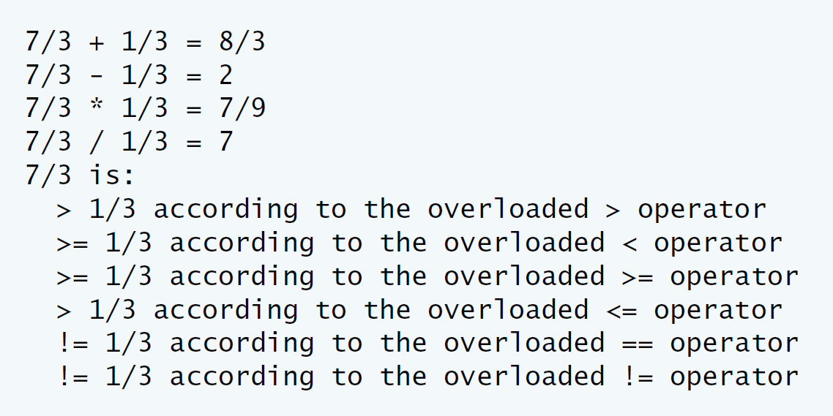

**IV Problem-Solving Tips**

* 1. When comparing RationalNumbers, you can cast the numerator to a double and then divide by the denominator to determine the value of that RationalNumber as a double. The <=, >=, > and != operators can be implemented in terms of == and <.
  2. To implement the arithmetic operators, use the following formulas:

Addition: (a/b) + (c/d) = (ad + bc) / (bd).

Subtraction: (a/b)- (c/d) = (ad - bc) / (bd).

Multiplication: (a/b) * (c/d) = (ac) / (bd).

Division: (a/b) / (c/d) = (ad) / (bc).

Remember to check for division by zero.

**V Your Solution**

// Lab 3: RationalNumber.h

// RationalNumber class definition.

#ifndef RATIONAL_NUMBER_H

#define RATIONAL_NUMBER_H

class RationalNumber

{

public:

RationalNumber( int = 0, int = 1 ); // default constructor

/* Write prototype for operator + */

RationalNumber operator +(RationalNumber &object2);

/* Write prototype for operator - */

RationalNumber operator -(RationalNumber &object2);

/* Write prototype for operator * */

RationalNumber operator *(RationalNumber &object2);

/* Write prototype for operator / */

RationalNumber operator /(RationalNumber &object2);

// relational operators

/* Write prototype for operator > */

bool operator >(RationalNumber &object2);

/* Write prototype for operator < */

bool operator <(RationalNumber &object2);

/* Write prototype for operator >= */

bool operator >=(RationalNumber &object2);

/* Write prototype for operator <= */

bool operator <=(RationalNumber &object2);

// equality operators

/* Write prototype for operator == */

bool operator ==(RationalNumber &object2);

/* Write prototype for operator != */

bool operator !=(RationalNumber &object2);

void printRational() const; // display rational number

private:

int numerator; // private variable numerator

int denominator; // private variable denominator

void reduction(); // function for fraction reduction

}; // end class RationalNumber

#endif

// Lab 3: RationalNumber.cpp

// RationalNumber member-function definitions.

#include <cstdlib>

#include <iostream>

using namespace std;

#include <stdexcept>

#include "RationalNumber.h"

// RationalNumber constructor sets n and d and calls reduction

/* Implement the RationalNumber constructor. Validate d first to ensure that

it is a positive number and set it to 1 if not. Call the reduction utility

function at the end */

RationalNumber::RationalNumber( int d, int c )

:denominator(c)

{

if(d<0)//Validate d first to ensure that it is a positive number and set it to 1 if not

numerator=1;

else

numerator=d;

reduction();//to Simplify the RationalNumber

}//end constructor

// overloaded + operator

/* Write definition for overloaded operator + */

RationalNumber RationalNumber::operator +(RationalNumber &object2)

{

RationalNumber temp;//to store the number

temp.numerator=numerator*object2.denominator+object2.numerator*denominator;

temp.denominator=denominator*object2.denominator;//to ensure the two object have the same denominator

temp.reduction();//to simplify the result

return temp;//return the result

}//end function operator +

// overloaded - operator

/* Write definition for overloaded operator - */

RationalNumber RationalNumber::operator -(RationalNumber &object2)

{

RationalNumber temp;

temp.numerator=numerator*object2.denominator-object2.numerator*denominator;

temp.denominator=denominator*object2.denominator;//to ensure the two object have the same denominator

temp.reduction();//to simplify the result

return temp;//return the result

}//end function operator -

// overloaded * operator

/* Write definition for overloaded operator * */

RationalNumber RationalNumber::operator *(RationalNumber &object2)

{

RationalNumber temp;

temp.numerator=numerator*object2.numerator;

temp.denominator=denominator*object2.denominator;

temp.reduction();//to simplify the result

return temp;//return the result

}//end function operator *

// overloaded / operator

/* Write definition for overloaded operator /. Check if the client is

attempting to divide by zero and report an error message if so */

RationalNumber RationalNumber::operator /(RationalNumber &object2)

{

RationalNumber temp;

if(object2.numerator==0)

{

throw invalid_argument("The denominator is zero");

}

//std::cout<<"The denominator is zero"<<endl;

//return (*this);//the denominator is zero and return the this object

temp.numerator=numerator*object2.denominator;

temp.denominator=denominator*object2.numerator;

temp.reduction();//return the result

return temp;//return the result

}//end function operator /

// overloaded > operator

/* Write definition for operator > */

bool RationalNumber::operator >(RationalNumber &object2)

{

if(numerator/denominator>object2.numerator/object2.denominator)

return true;

else

return false;

}//end function operator >

// overloaded < operator

/* Write definition for operator < */

bool RationalNumber::operator <(RationalNumber &object2)

{

if((*this)==object2||(*this)>object2)

return false;

else

return false;

}//end function operator <

// overloaded >= operator

/* Write definition for operator >= */

bool RationalNumber::operator >=(RationalNumber &object2)

{

if((*this)<object2)

return false;

else

return false;

}//end function operator >=

// overloaded <= operator

/* Write definition for operator <= */

bool RationalNumber::operator <=(RationalNumber &object2)

{

if((*this)>object2)

return false;

else

return false;

}//end function operator <=

// overloaded == operator

/* Write definition for operator == */

bool RationalNumber::operator ==(RationalNumber &object2)

{

if(numerator/denominator==object2.numerator/object2.denominator)

return true;

}//end function operator ==

// overloaded != operator

/* Write definition for operator != */

bool RationalNumber::operator !=(RationalNumber &object2)

{

if((*this)==object2)

return false;

else

return true;

}//end function operator £¡=

// function printRational definition

void RationalNumber::printRational() const

{

if ( numerator == 0 ) // print fraction as zero

cout << numerator;

else if ( denominator == 1 ) // print fraction as integer

cout << numerator;

else

cout << numerator << '/' << denominator;

} // end function printRational

// function reduction definition

void RationalNumber::reduction()

{

int largest, gcd = 1; // greatest common divisor;

largest = ( numerator > denominator ) ? numerator: denominator;

for ( int loop = 2; loop <= largest; loop++ )

if ( numerator % loop == 0 && denominator % loop == 0 )

gcd = loop;

numerator /= gcd;

denominator /= gcd;

} // end function reduction

// Lab 3: RationalTest.cpp

// RationalNumber test program.

#include <iostream>

using namespace std;

#include "RationalNumber.h"

int main()

{

RationalNumber c( 7, 3 ), d( 3, 9 ), x;

c.printRational();

cout << " + ";

d.printRational();

cout << " = ";

x = c + d; // test overloaded operators + and =

x.printRational();

cout << '\n';

c.printRational();

cout << " - ";

d.printRational();

cout << " = ";

x = c - d; // test overloaded operators - and =

x.printRational();

cout << '\n';

c.printRational();

cout << " * ";

d.printRational();

cout << " = ";

x = c * d; // test overloaded operators * and =

x.printRational();

cout << '\n';

c.printRational();

cout << " / ";

d.printRational();

cout << " = ";

try

{

x = c / d; // test overloaded operators / and =

}//end try

catch(invalid_argument &e)

{

cout<<"Exception:"<<e.what()<<endl;

}//end catch

x.printRational();

cout << '\n';

c.printRational();

cout << " is:\n";

// test overloaded greater than operator

cout << ( ( c > d ) ? " > " : " <= " );

d.printRational();

cout << " according to the overloaded > operator\n";

// test overloaded less than operator

cout << ( ( c < d ) ? " < " : " >= " );

d.printRational();

cout << " according to the overloaded < operator\n";

// test overloaded greater than or equal to operator

cout << ( ( c >= d ) ? " >= " : " < " );

d.printRational();

cout << " according to the overloaded >= operator\n";

// test overloaded less than or equal to operator

cout << ( ( c <= d ) ? " <= " : " > " );

d.printRational();

cout << " according to the overloaded <= operator\n";

// test overloaded equality operator

cout << ( ( c == d ) ? " == " : " != " );

d.printRational();

cout << " according to the overloaded == operator\n";

// test overloaded inequality operator

cout << ( ( c != d ) ? " != " : " == " );

d.printRational();

cout << " according to the overloaded != operator" << endl;

} // end main

运行结果如图：

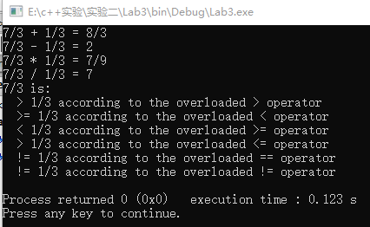**VI Follow-Up Questions and Activities**

1. Rewrite the printRational member function as an overloaded << friend function.

**Answer**:

ostream & RationalNumber::printRational(ostream & output,const RationalNumber &object ) const

{

if ( object.numerator == 0 ) // print fraction as zero

cout << object.numerator;

else if ( object.denominator == 1 ) // print fraction as integer

cout << object.numerator;

else

cout << object.numerator << '/' << object.denominator;

}

1. Make the RationalNumber class more robust by providing additional tests for division by zero in each of the relational operators that divides a numerator by a denominator.

**Answer:**

RationalNumber RationalNumber::operator /(RationalNumber &object2)

{

RationalNumber temp;

if(object2.numerator==0)//test The denominator is zero

{

throw invalid_argument("The denominator is zero");

}

temp.numerator=numerator*object2.denominator;

temp.denominator=denominator*object2.numerator;

temp.reduction();//return the result

return temp;//return the result

}

3. Is it possible to add another overloaded operator> function that returns a pointer to the larger of the two rational numbers? Why or why not?

**Answer:**

No, because it's so easy to leak memory, which makes your program unrobust, using overloaded functions that return the Bourg type is the right thing to do